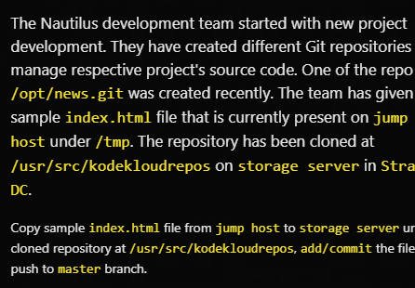

SOLUTION

Scp /tmp/index.html natasha@ststor01:/tmp

Ssh natasha@ststor01

Cd /usr/src/kodekloudrepos/games

Cp /tmp/index.html .

Git add index.html

Git commit -m “add index.html”

Git push -u origin master